Kubernetes task-07
Task 1: Execute all yaml files shown in video.
- Check Nodes
kubectl get nodes
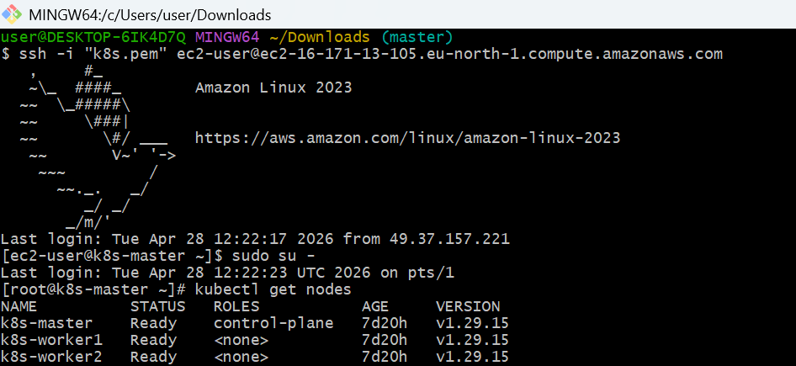
- Add Labels to Node (IMPORTANT)
We assign labels so pods can target nodes.
kubectl label nodes k8s-worker1 disktype=ssd
- kubectl label nodes k8s-worker2 env=prod
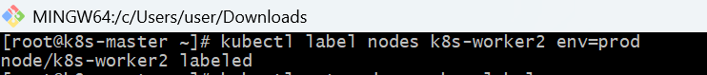
- Verify:
kubectl get nodes --show-labels
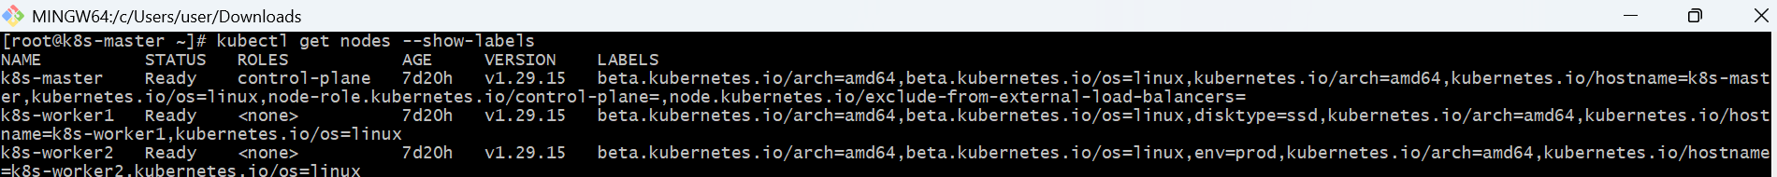
- Create NodeSelector Pod
Create file:
vi nodeselector.yaml
Paste:
apiVersion: v1
kind: Pod
metadata:
name: nodeselector-pod
spec:
containers:
- name: nginx
image: nginx
nodeSelector:
disktype: ssd
- Run:
kubectl apply -f nodeselector.yaml
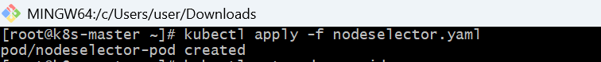
- kubectl get pods -o wide
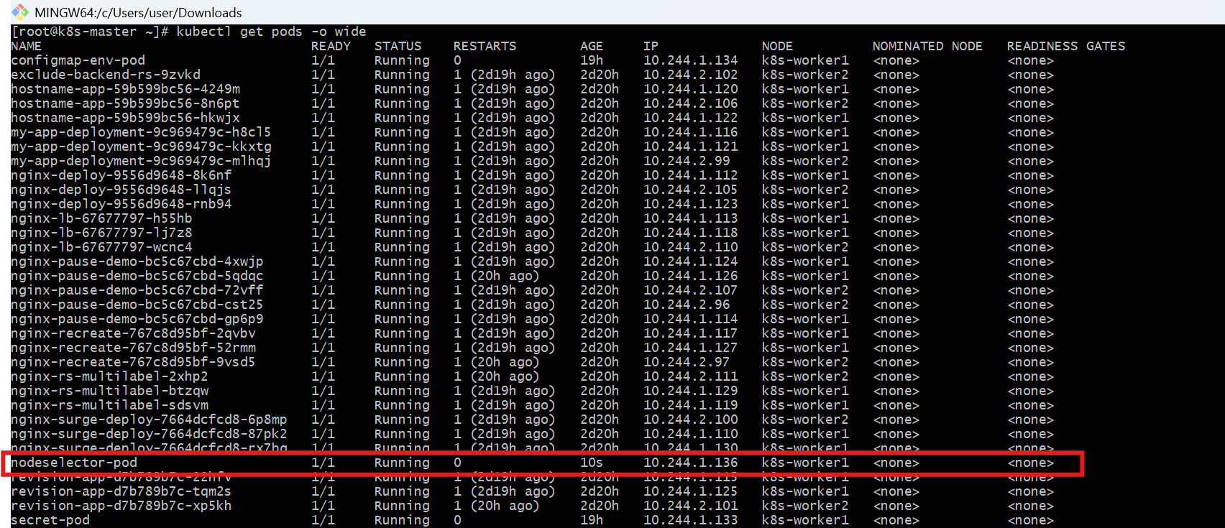
- Create NodeAffinity Pod
vi nodeaffinity.yaml
Paste:
apiVersion: v1
kind: Pod
metadata:
name: nodeaffinity-pod
spec:
containers:
- name: nginx
image: nginx
affinity:
nodeAffinity:
requiredDuringSchedulingIgnoredDuringExecution:
nodeSelectorTerms:
- matchExpressions:
- key: env
operator: In
values:
- prod
Run:
kubectl apply -f nodeaffinity.yaml
- kubectl get pods -o wide
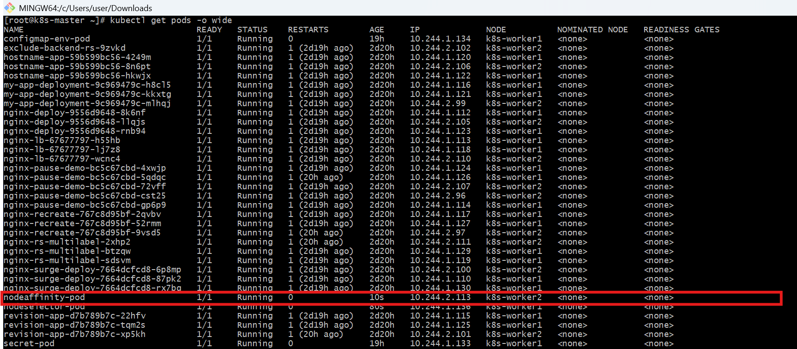
- Apply Taint to Node
kubectl taint nodes k8s-worker2 env=prod:NoSchedule
kubectl describe node k8s-worker2 | grep Taint
- Create Toleration Pod
vi toleration.yaml
Paste:
apiVersion: v1
kind: Pod
metadata:
name: toleration-pod
spec:
containers:
- name: nginx
image: nginx
tolerations:
- key: "env"
operator: "Equal"
value: "prod"
effect: "NoSchedule"

- kubectl apply -f toleration.yaml
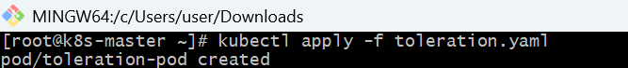
- kubectl get pods -o wide
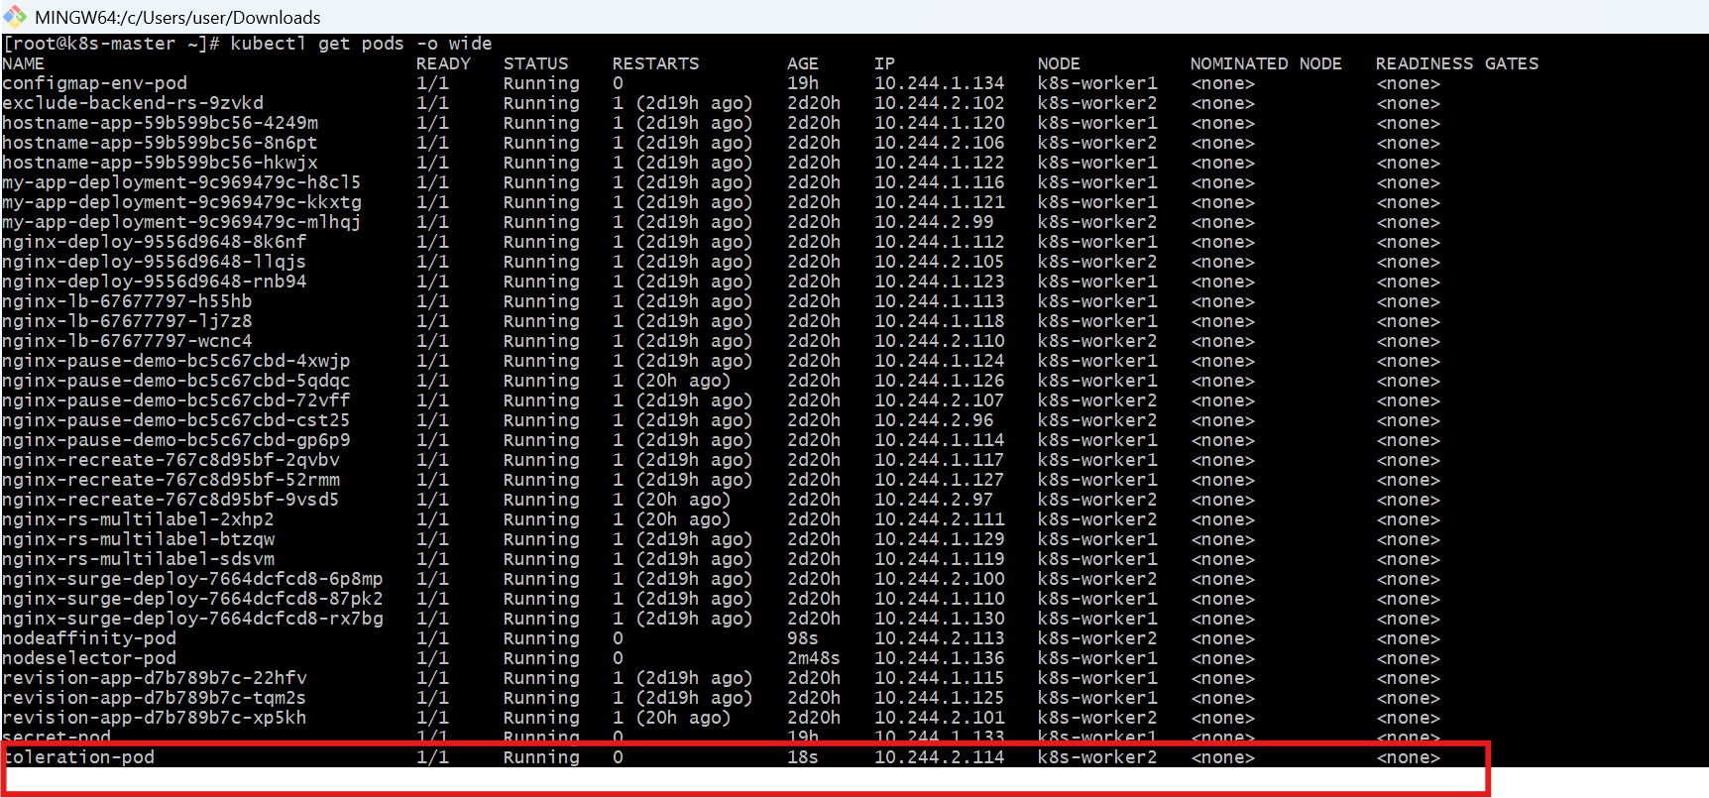
- Verify Everything
kubectl describe pod nodeselector-pod
kubectl describe pod nodeaffinity-pod
kubectl describe pod toleration-pod
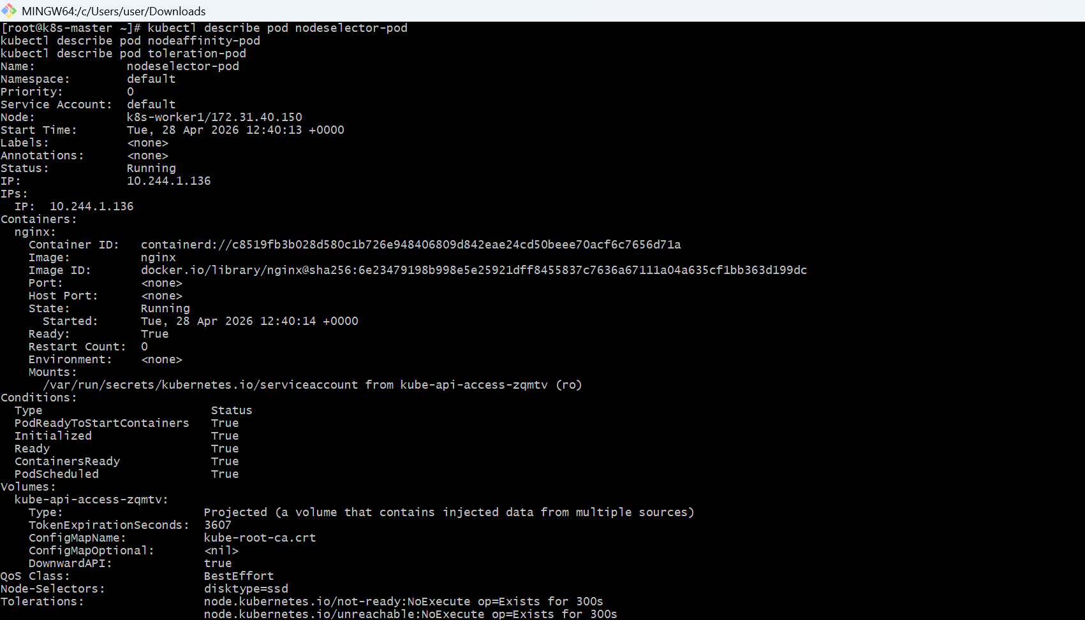
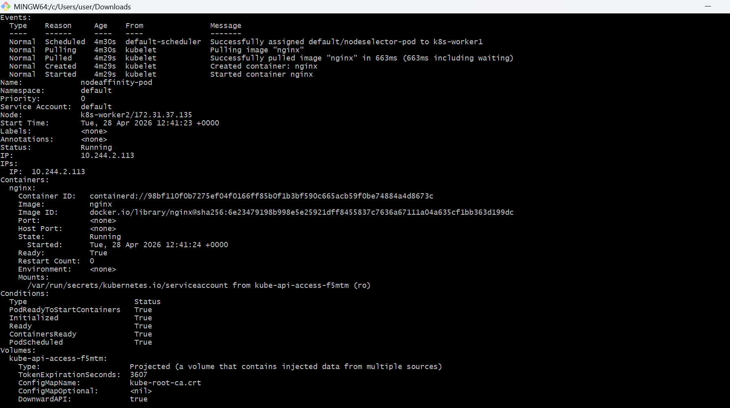
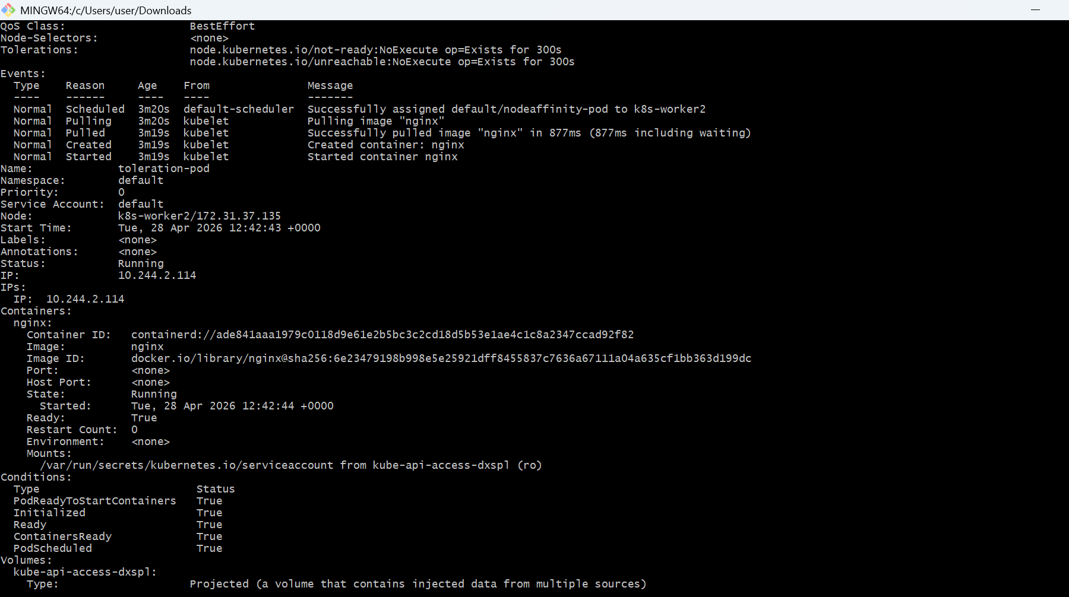
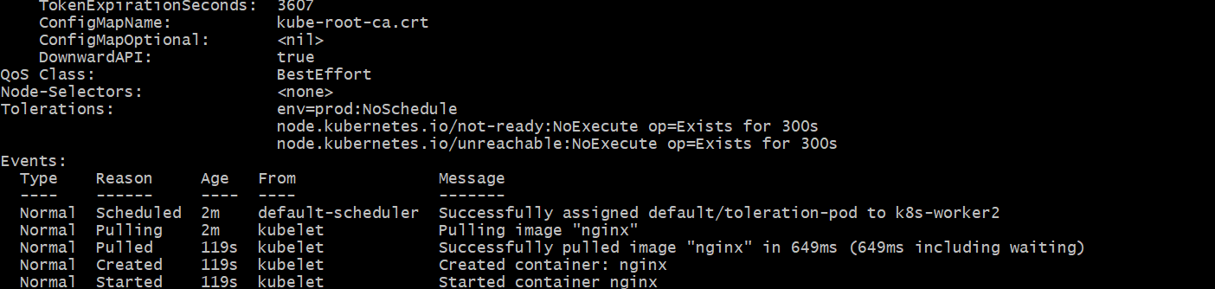
- Cleanup
kubectl delete pod nodeselector-pod
kubectl delete pod nodeaffinity-pod
kubectl delete pod toleration-pod
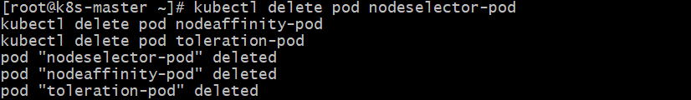
- kubectl taint nodes node2 env=prod:NoSchedule-
Task 2: Taint a Node and Schedule a Tolerant Pod Taint a node with special=true:NoSchedule. Create a pod with a toleration that matches the taint, allowing it to be scheduled on the tainted node.
- Check available nodes
kubectl get nodes
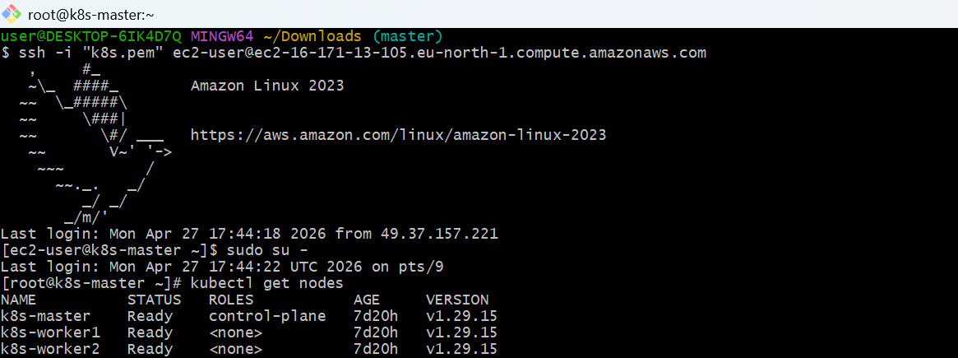
- Apply Taint to Node
Syntax:
kubectl taint nodes <node-name> key=value:effect
Your task:
kubectl taint nodes k8s-worker2 special=true:NoSchedule
- Verify Taint
kubectl describe node k8s-worker2 | grep -i taint
Create file:
vi tolerant-pod.yaml
Paste this:

apiVersion: v1
kind: Pod
metadata:
name: tolerant-pod
spec:
containers:
- name: nginx
image: nginx
nodeSelector:
kubernetes.io/hostname: k8s-worker2 # 👈 force node
tolerations:
- key: "special"
operator: "Equal"
value: "true"
effect: "NoSchedule"
- Apply Pod
kubectl apply -f tolerant-pod.yaml
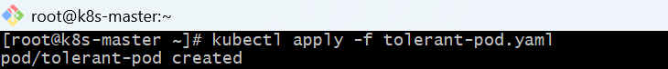
- Check Pod Status
kubectl get pods -o wide
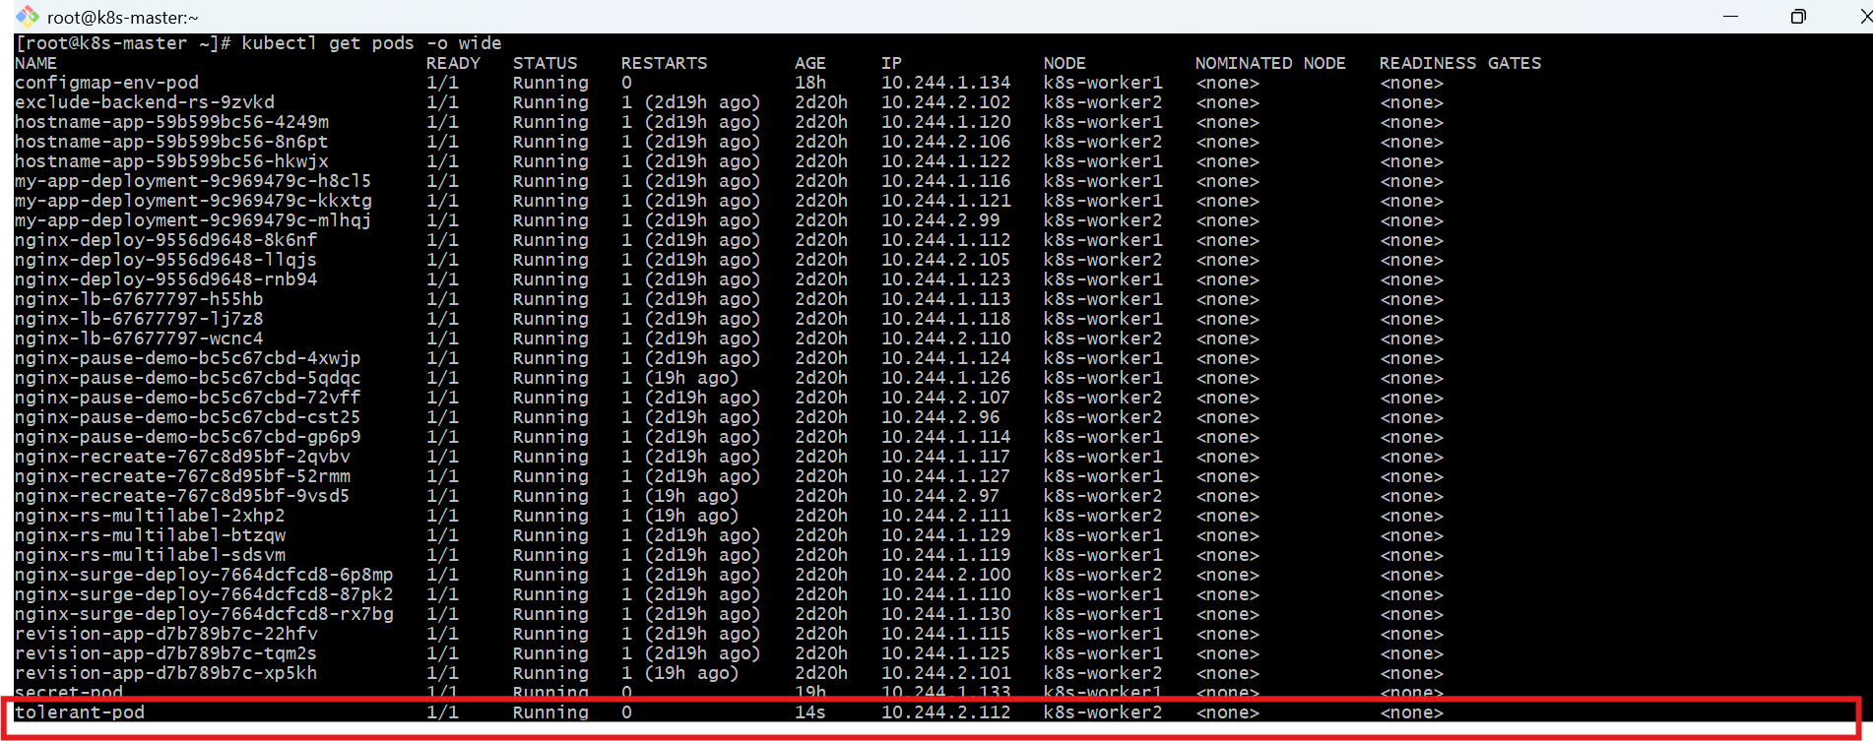
- Verify Scheduling
kubectl describe pod tolerant-pod
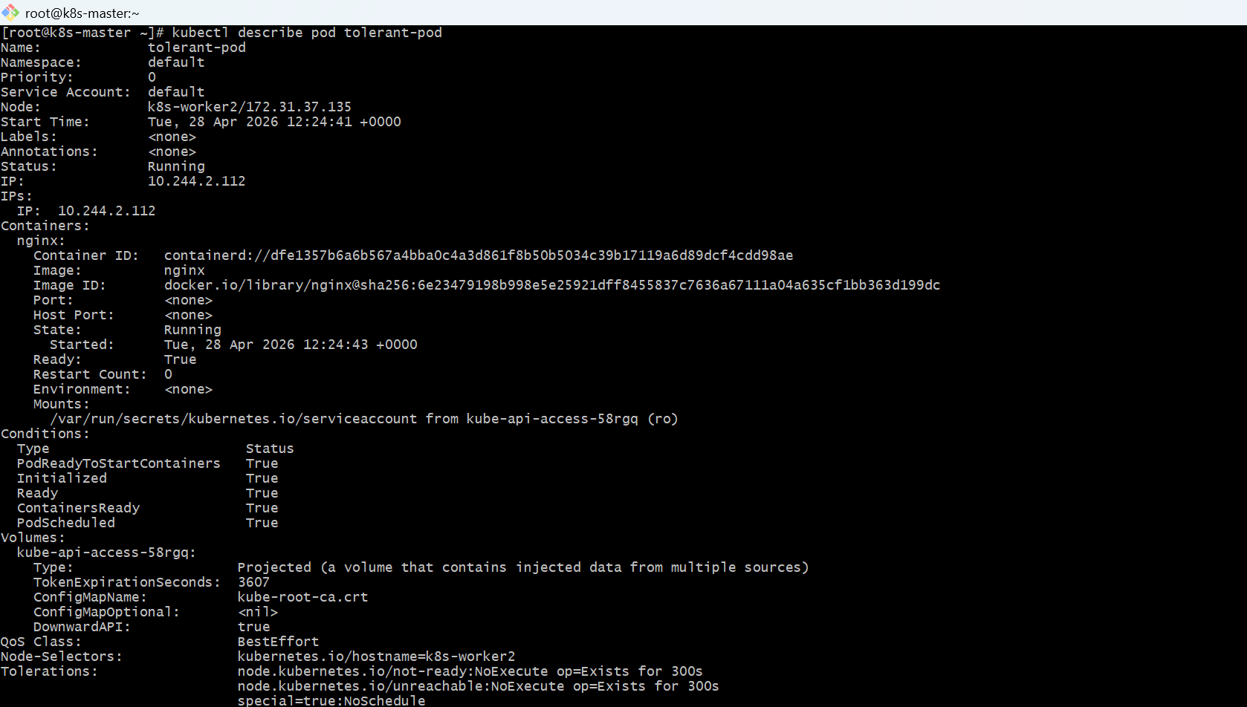
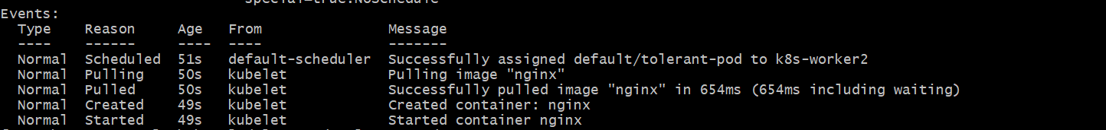
Cleanup
kubectl delete pod tolerant-pod

kubectl taint nodes k8s-worker2 special=true:NoSchedule-
Task 3: Use NodeSelector to Schedule a Pod on a Specific Node Label a node with env=dev. Create a pod with a nodeSelector that schedules it only on the node labeled env=dev.
- Label the Node
First, check your nodes:
kubectl get nodes
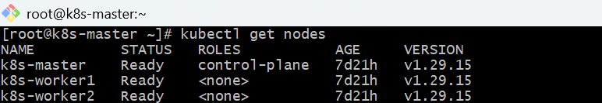
- Label one worker node
Let’s label k8s-worker1:
kubectl label nodes k8s-worker1 env=dev
Verify:
kubectl get nodes --show-labels
- Create Pod YAML
Create file:
vi pod-nodeselector.yaml
Paste:
apiVersion: v1
kind: Pod
metadata:
name: nginx-dev-pod
spec:
containers:
- name: nginx
image: nginx
nodeSelector:
env: dev
- Apply the Pod
kubectl apply -f pod-nodeselector.yaml
- Verify Scheduling
kubectl get pods -o wide
Output should show:
nginx-dev-pod Running ... NODE: k8s-worker1
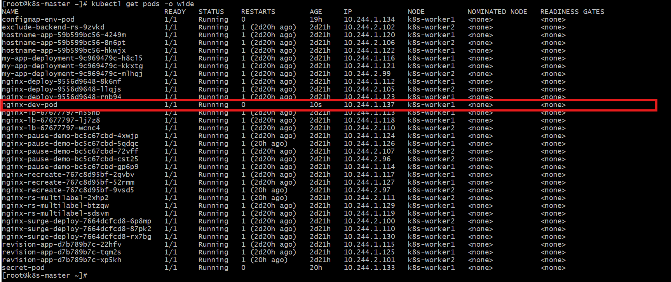
Task 4: Use Node Affinity with Soft Scheduling Label a node with env=test. Create a pod with PreferredDuringSchedulingIgnoredDuringExecution node affinity, preferring to schedule it on a node labeled env=test. Remove the label and verify the pod continues to run.
- Check node names
kubectl get nodes
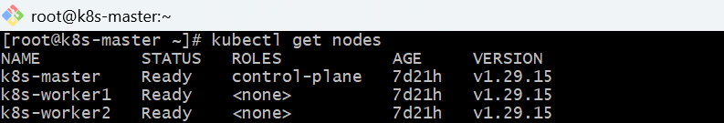
Since your requirement is env=test, update one node:
kubectl label node k8s-worker1 env=test –overwrite
- Verify:
kubectl get nodes --show-labels
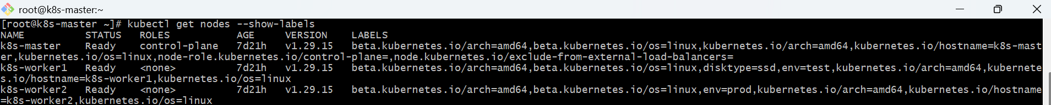
- Create pod YAML with soft node affinity
vi soft-affinity-pod.yaml
Paste:
apiVersion: v1
kind: Pod
metadata:
name: soft-affinity-pod
spec:
affinity:
nodeAffinity:
preferredDuringSchedulingIgnoredDuringExecution:
- weight: 100
preference:
matchExpressions:
- key: env
operator: In
values:
- test
containers:
- name: nginx
image: nginx
- Apply:
kubectl apply -f soft-affinity-pod.yaml
- Verify pod scheduled
kubectl get pod soft-affinity-pod -o wide
Check node:
kubectl describe pod soft-affinity-pod
It should prefer the node with label:
env=test
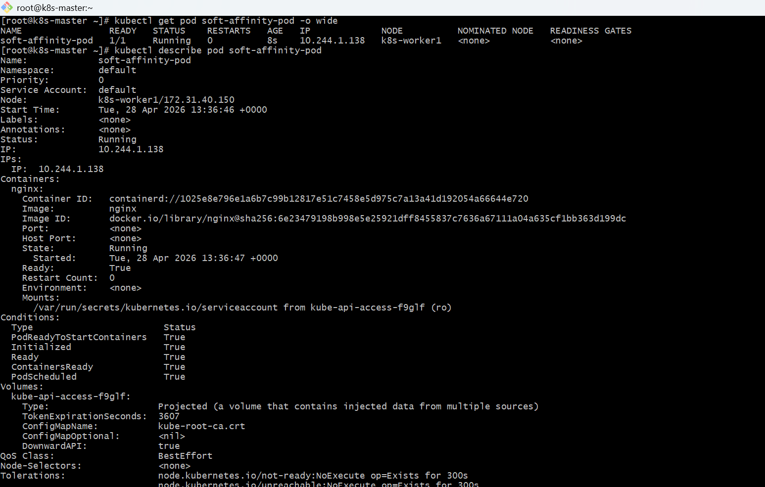
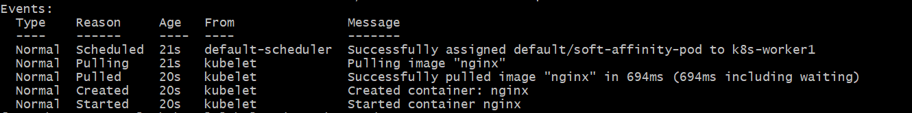
- Remove the label from node
kubectl label node k8s-worker1 env-
- Verify label removed:
kubectl get nodes --show-labels
- Verify pod still running
kubectl get pod soft-affinity-pod -o wide
Expected:
soft-affinity-pod 1/1 Running
Task 5: Implement Node Affinity with Hard Scheduling Create a pod with RequiredDuringSchedulingIgnoredDuringExecution node affinity, ensuring it will only be scheduled on a node labeled env=prod. Verify the pod cannot be scheduled if no node has the env=prod label.
- Check existing node labels
kubectl get nodes --show-labels.
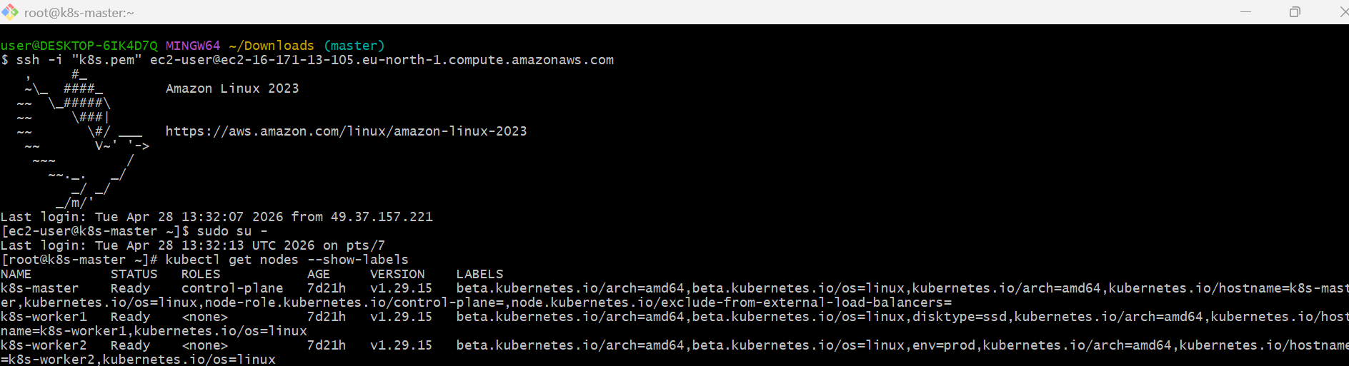
- Create hard node affinity pod YAML
vi hard-affinity-pod.yaml
Paste:
apiVersion: v1
kind: Pod
metadata:
name: hard-affinity-pod
spec:
containers:
- name: nginx
image: nginx
affinity:
nodeAffinity:
requiredDuringSchedulingIgnoredDuringExecution:
nodeSelectorTerms:
- matchExpressions:
- key: env
operator: In
values:
- prod
- Apply:
kubectl apply -f hard-affinity-pod.yaml
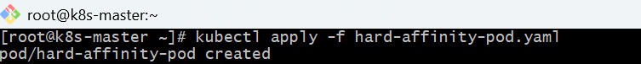
- Verify scheduling
kubectl get pod hard-affinity-pod -o wide
kubectl describe pod hard-affinity-pod
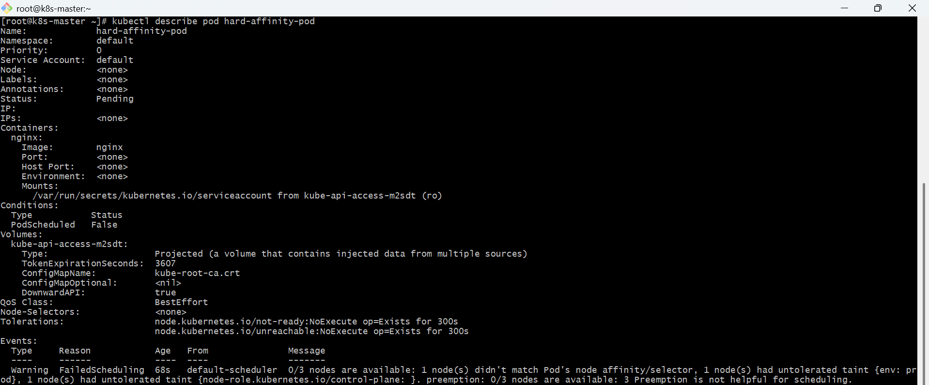
- Add env=prod label to one node
Example:
kubectl label node k8s-worker2 env=prod –overwrite
- Verify:
kubectl get nodes --show-labels
- Now check pod:
kubectl get pod hard-affinity-pod -o wide
It should become Running on the node labeled env=prod.
- Remove label and verify pod continues running
kubectl label node k8s-worker2 env-
kubectl get pod hard-affinity-pod -o wide
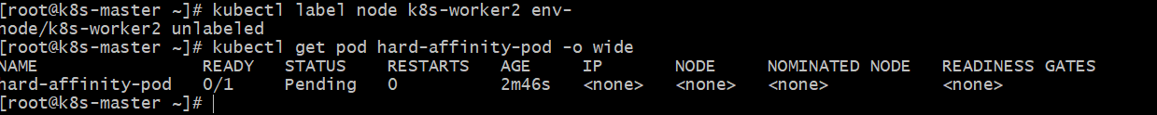
Task 6: Taint a Node and Use NoExecute with Toleration Seconds Taint a node with special=true:NoExecute. Create a pod with a tolerationSeconds field (e.g., 60 seconds) and observe it gets evicted after 60 seconds on the tainted node.
- Check your node names
kubectl get nodes
Example:
k8s-master
k8s-worker1
k8s-worker2
Choose one worker node, example: k8s-worker1.
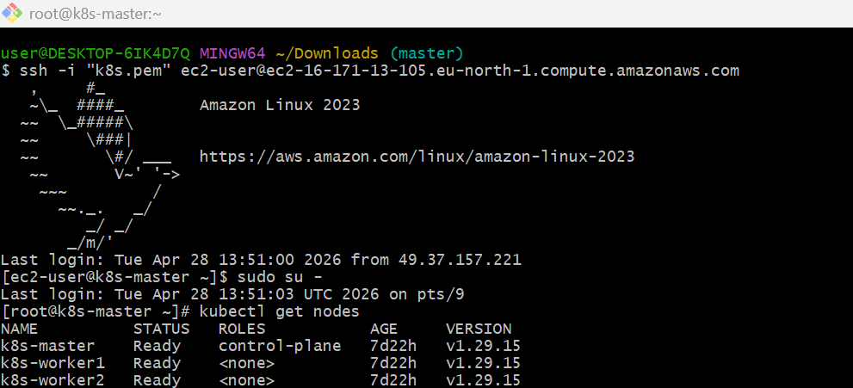
- Taint the node with NoExecute
kubectl taint node k8s-worker1 special=true:NoExecute
Check:
kubectl describe node k8s-worker1 | grep -i taint
- Create pod YAML with tolerationSeconds
vi noexecute-pod.yaml
Paste:
apiVersion: v1
kind: Pod
metadata:
name: noexecute-demo
spec:
nodeName: k8s-worker1
tolerations:
- key: "special"
operator: "Equal"
value: "true"
effect: "NoExecute"
tolerationSeconds: 60
containers:
- name: nginx
image: nginx
- Apply:
kubectl apply -f noexecute-pod.yaml
- Observe pod running first
kubectl get pod noexecute-demo -o wide
It should run on k8s-worker1.
- Wait 60 seconds and check again
kubectl get pod noexecute-demo -o wide
After around 60 seconds, pod should be evicted/deleted.
- Check events:
kubectl describe pod noexecute-demo
- Remove taint after practice
kubectl taint node k8s-worker1 special=true:NoExecute-
- Check:
kubectl describe node k8s-worker1 | grep -i taint

